A systematic review of research using

the Implicit Relational Assessment Procedure (2006-2022)

Ian Hussey

Here I provide a systematic review of published research using the Implicit Relational Assessment Procedure (IRAP). This manuscript does not perform any synthesis of the research, it merely describes the search and exclusion process of this systematic review. The publications returned by this systematic review can be used in other work that seeks to do such syntheses (e.g., reviews of methods or findings).

The Implicit Relational Assessment Procedure (IRAP: Barnes-Holmes et al., 2006) is a reaction-time based task used variously as an implicit measure and a measure of the strength of relational responding (Hughes et al., 2012). In order to facilitate systematic study of the IRAP literature, I performed a systematic review of all published literature employing the IRAP.

# Method & Results

Both the Web of Science and psycINFO databases were searched. Boolean search terms for the Web of Science database were “implicit relational assessment procedure” OR “IRAP” in the title, abstract, or keywords. Search constraints were publication date between 2006 and 2022, limited to publications in English. The search was run on 23 December 2018. The systematic review was updated with a second search run on 11 September 2022. Results from both searches were integrated. Results of each stage of this review are computationally reproducible: bibtex files for all articles at each stage of the search and exclusion process are available in the supplementary materials.

A PRISMA flow chart detailing all exclusions can be found in Figure 1 (Moher et al., 2009). After duplicates were removed, 231 records remained. These were screened based on their title and abstract. Inclusion criterion was the use of the Implicit Relational Assessment Procedure (IRAP) within the study. Variant procedures such as the Mixed-Trials IRAP (MT-IRAP: Levin et al., 2010) and the Training IRAP (T-IRAP: Kilroe et al., 2014) were excluded. 160 records remained after title and abstract exclusions. The full texts of these articles was then screened using the same inclusion criterion. Five articles were excluded based on this full text search. In four of these cases, we sought additional details of the procedure used from the authors of the articles. Based on the information provided, four articles were excluded for employing a task other than a standard IRAP (Baker et al., 2015, 2017; Smith et al., 2022; Szarko et al., 2022). The fifth article was excluded because it did not employ an IRAP, although this was not initially apparent from its title and abstract (Perez et al., 2020). After all exclusions, 155 published articles and book chapters using the IRAP were returned by the review. A complete list of these publications is available in .csv format (<https://osf.io/d289f>). The supplementary materials also include other formats (e.g., bibtex: [osf.io/tna8s](https://osf.io/tna8s/)).

**Figure 1.** PRISMA flow chart for systematic review

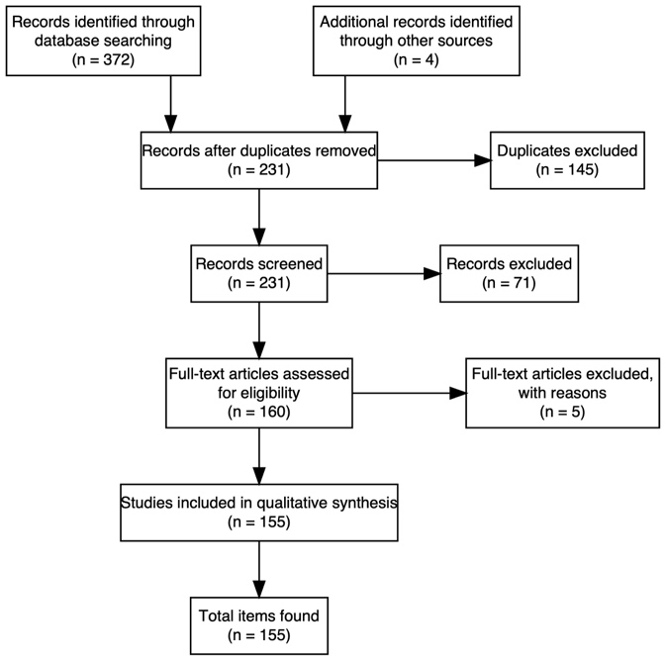

# Discussion

It is hoped that this publicly available, open source systematic review of research using the IRAP will facilitate future evidence synthesis and meta-scientific research on the IRAP literature. Readers are free to use, modify, and update the review and its materials. At least one manuscript has made use of the review to date (Hussey, 2022).

# Author note

Ian Hussey, Ruhr University Bochum, Germany. [ian.hussey@rub.de](mailto:ian.hussey@rub.de).

# Statements and Declarations

## Conflict of Interest

The author declares that he has no relevant financial or non-financial interests to disclose.

## Funding

This research was supported by the META-REP Priority Program of the German Research Foundation (#464488178).

## Availability of data, code and materials

All data, code and materials are available at [osf.io/tna8s](https://osf.io/tna8s/).

# References

Baker, T. K., Schwenk, T., Piasecki, M., Smith, G. S., Reimer, D., Jacobs, N., Shonkwiler, G., Hagen, J., & Houmanfar, R. A. (2015). Cultural Change in a Medical School: A Data-Driven Management of Entropy. *Journal of Organizational Behavior Management*, *35*(1–2), 95–122. https://doi.org/10.1080/01608061.2015.1035826

Baker, T. K., Smith, G. S., Jacobs, N. N., Houmanfar, R., Tolles, R., Kuhls, D., & Piasecki, M. (2017). A deeper look at implicit weight bias in medical students. *Advances in Health Sciences Education*, *22*(4), 889–900. https://doi.org/10.1007/s10459-016-9718-1

Barnes-Holmes, D., Barnes-Holmes, Y., Power, P., Hayden, E., Milne, R., & Stewart, I. (2006). Do you really know what you believe? Developing the Implicit Relational Assessment Procedure (IRAP) as a direct measure of implicit beliefs. *The Irish Psychologist*, *32*(7), 169–177.

Hughes, S., Barnes-Holmes, D., & Vahey, N. A. (2012). Holding on to our functional roots when exploring new intellectual islands: A voyage through implicit cognition research. *Journal of Contextual Behavioral Science*, *1*(1–2), 17–38. https://doi.org/10.1016/j.jcbs.2012.09.003

Hussey, I. (2022). *Reply to Barnes-Holmes & Harte (2022) “The IRAP as a Measure of Implicit Cognition: A Case of Frankenstein’s Monster.”* PsyArXiv. https://doi.org/10.31234/osf.io/qmg6s

Kilroe, H., Murphy, C., Barnes-Holmes, D., & Barnes-Holmes, Y. (2014). Using the T-IRAP interactive computer program and applied behavior analysis to teach relational responding in children with autism. *Behavioral Development Bulletin*, *19*(2), 60–80. psyh. https://doi.org/10.1037/h0100578

Levin, M. E., Hayes, S. C., & Waltz, T. (2010). Creating an implicit measure of cognition more suited to applied research: A test of the Mixed Trial—Implicit Relational Assessment Procedure (MT-IRAP). *International Journal of Behavioral Consultation and Therapy*, *6*(3), 245–262. psyh. https://doi.org/10.1037/h0100911

Moher, D., Liberati, A., Tetzlaff, J., & Altman, D. G. (2009). Preferred reporting items for systematic reviews and meta-analyses: The PRISMA statement. *BMJ*, *339*, b2535. https://doi.org/10.1136/bmj.b2535

Perez, W. F., de Almeida, J. H., Soares, L. C. C. S., Wang, T. F. L., de Morais, T. E. D. G., Mascarenhas, A. V., & de Rose, J. C. (2020). Fearful Faces and the Derived Transfer of Aversive Functions. *The Psychological Record*. https://doi.org/10.1007/s40732-020-00390-6

Smith, G. S., Houmanfar, R. A., Jacobs, N. N., Froehlich, M., Szarko, A. J., Smith, B. M., Kemmelmeier, M., Baker, T. K., Piasecki, M., & Schwenk, T. L. (2022). Assessment of medical student burnout: Toward an implicit measure to address current issues. In *ADVANCES IN HEALTH SCIENCES EDUCATION* (Vol. 27, Issue 2, pp. 375–386). SPRINGER. https://doi.org/10.1007/s10459-021-10089-0

Szarko, A. J., Houmanfar, R. A., Smith, G. S., Jacobs, N. N., Smith, B. M., Assemi, K., Piasecki, M., & Baker, T. K. (2022). Impact of Acceptance and Commitment Training on psychological flexibility and burnout in medical education. In *JOURNAL OF CONTEXTUAL BEHAVIORAL SCIENCE* (Vol. 23, pp. 190–199). ELSEVIER. https://doi.org/10.1016/j.jcbs.2022.02.004